Amazon Sales Analysis and Interactive Dashboard
Abstract
The rapid growth of e-commerce platforms has resulted in massive volumes of transactional data generated daily. Amazon, being one of the world’s largest e-commerce companies, relies heavily on data-driven insights to understand customer behavior, product performance, and revenue trends. This project focuses on analyzing Amazon sales data and presenting meaningful insights through an interactive dashboard. The dashboard highlights key performance indicators such as total revenue, quantity sold, product ratings, regional performance, and payment method distribution. The project demonstrates how business intelligence and data visualization tools can be effectively used to support strategic decision-making in the e-commerce domain.

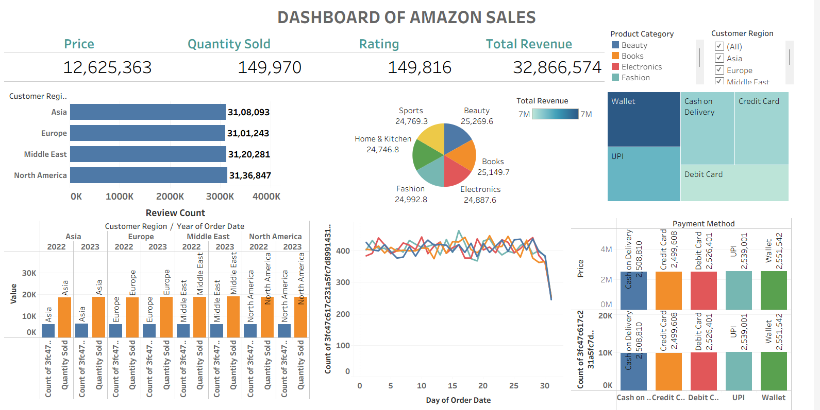

1. Introduction
E-commerce platforms handle millions of transactions across diverse product categories and customer regions. Analyzing such data manually is inefficient and prone to errors. Business Intelligence (BI) dashboards provide a visual and interactive way to analyze complex datasets.
This final year project aims to design and develop an Amazon Sales Dashboard that provides a comprehensive overview of sales performance across regions, product categories, and payment methods. The dashboard helps stakeholders track performance, identify trends, and make informed business decisions.

2. Objectives of the Project
The main objectives of this project are:
- To analyze Amazon sales data using data analytics techniques
- To calculate and visualize important KPIs
- To study regional and category-wise sales performance
- To analyze customer purchasing and payment behavior
- To design an interactive and user-friendly sales dashboard

3. Dataset Summary
The dataset used in this project consists of Amazon sales transaction records collected over multiple regions and time periods. Each record represents a customer order with relevant sales attributes.
3.1 Dataset Attributes
The key columns included in the dataset are:
- Order Date: Date on which the order was placed
- Product Category: Category of product (Beauty, Books, Electronics, Fashion, Sports, Home & Kitchen)
- Price: Price of the product
- Quantity Sold: Number of units sold
- Rating: Customer rating given to the product
- Customer Region: Region of the customer (Asia, Europe, Middle East, North America)
- Payment Method: Mode of payment (Credit Card, Debit Card, UPI, Wallet, Cash on Delivery)
- Revenue: Total revenue generated per order.

3.2 Data Pre-processing
The following data preparation steps were performed before dashboard creation:
- Removal of duplicate records
- Handling missing values
- Formatting date fields
- Creating calculated measures such as total revenue and average rating
- Categorization of regions and payment methods

4. Tools and Technologies Used
- Data Visualization Tool: Power BI
- Dataset Format: Excel / CSV
- Operating System: Windows
- Techniques Used: Data aggregation, KPI calculation, filtering, and visual analytics

5. Key Performance Indicators (KPI) Explanation
5.1 Total Price
- Value Displayed: 12,625,363
- Description: Represents the total price value of products sold.
- Business Insight: Helps measure the overall sales value before aggregation into revenue.
5.2 Quantity Sold
- Value Displayed: 149,970
- Description: Total number of units sold across all categories and regions.
- Business Insight: Indicates overall sales volume and demand.
5.3 Rating
- Value Displayed: 149,816
- Description: Total count of ratings received from customers.
- Business Insight: Reflects customer engagement and satisfaction level.

5.4 Total Revenue
- Value Displayed: 32,866,574
- Description: Total revenue generated from all orders.
- Business Insight: Serves as the primary financial performance metric.

6. Dashboard Analysis
6.1 Revenue by Customer Region
This bar chart shows total revenue generated across different customer regions:
- North America and Asia contribute the highest revenue.
- Europe and the Middle East show steady and consistent performance.
6.2 Revenue by Product Category
The pie chart represents revenue contribution from different product categories:
- Beauty and Books categories contribute a significant share.
- Electronics and Fashion show balanced revenue distribution.
- Sports and Home & Kitchen demonstrate growing demand.
6.3 Payment Method Analysis
The treemap visual displays revenue distribution by payment method:
- Digital payments such as UPI and Wallet show high adoption.
- Credit and Debit Cards contribute significantly to revenue.
- Cash on Delivery still holds a considerable share, indicating customer trust issues in some regions.
6.4 Review Count and Quantity Sold Analysis
This visualization compares review count and quantity sold across regions and years:
- Higher sales volume generally results in higher customer reviews.
- Consistent growth is observed across regions from 2022 to 2023.
6.5 Sales Trend by Day of Order Date
The line chart shows daily sales trends:
- Sales remain stable throughout most of the month.
- Sudden drops indicate weekends, low-demand days, or promotional gaps.

7. Methodology
The project follows a structured analytical approach:
- Requirement Gathering
- Data Collection
- Data Cleaning and Transformation
- Data Modeling
- KPI Identification
- Dashboard Design
- Testing and Validation
- Result Interpretation

8. System Architecture
The system architecture includes:
- Data Source (Amazon Sales Dataset)
- Data Preprocessing Layer
- Data Modeling and Measure Calculation
- Visualization Layer (Dashboard)
- End User Interaction

9. Results and Findings
- Digital payment methods dominate overall revenue.
- North America is the most profitable region.
- Customer ratings strongly correlate with quantity sold.
- Balanced revenue contribution across multiple product categories reduces business risk.

10. Advantages of the System
- Interactive and easy-to-understand dashboard
- Faster decision-making using real-time insights
- Identifies high-performing regions and products
- Reduces manual reporting effort

11. Limitations
- Dataset is limited to historical data
- Real-time streaming data is not included
- External factors such as promotions and logistics are not considered

12. Future Scope
- Integration of real-time sales data
- Customer behavior and churn analysis
- Sales forecasting using machine learning
- Personalized recommendation analysis
- Cloud-based dashboard deployment

13. Business Use Cases
The Amazon Sales Dashboard can be effectively used in several real-world business scenarios:
- Sales Performance Monitoring: Management can track daily, monthly, and yearly sales performance.
- Regional Strategy Planning: Helps identify high-revenue regions and regions requiring promotional focus.
- Product Category Optimization: Enables comparison of product categories to decide inventory and marketing priorities.
- Payment Behavior Analysis: Assists in understanding customer payment preferences to improve checkout experience.
- Customer Satisfaction Tracking: Ratings and reviews help evaluate product quality and service levels.

14. Data Flow Diagram (DFD) Description
Level 0 DFD (Context Diagram)
The system accepts Amazon sales data as input from Excel or CSV files. The data is processed using a BI tool and displayed as an interactive dashboard for end users such as analysts and managers.
Level 1 DFD
- Data Collection from transaction datasets
- Data Cleaning and Transformation
- KPI and Measure Calculation
- Visualization and Dashboard Generation
- User Interaction through filters and slicers

15. Testing and Validation
To ensure the accuracy and reliability of the dashboard, the following tests were conducted:
- Verification of revenue and quantity calculations
- Cross-checking KPI values with source data
- Testing filters for region, category, and payment method
- Ensuring dashboard responsiveness and usability

16. Security and Data Privacy Considerations
- Sensitive customer information is anonymized
- Access to the dashboard is restricted to authorized users
- Dataset used is for academic and analytical purposes only

17. Conclusion
This project successfully demonstrates how Amazon sales data can be analyzed using business intelligence tools to extract valuable insights. The Amazon Sales Dashboard provides a comprehensive view of revenue, customer behavior, and sales performance. Such dashboards play a crucial role in strategic planning, performance monitoring, and decision-making in modern e-commerce businesses.

14. References
- Amazon Public Dataset Resources
- Tableau Public Official Documentation
- Business Intelligence and Data Analytics Literature

